BHARATI VIDYAPEETH’S COLLEGE OF ENGINEERING FOR WOMEN

FDP ON

“RESEARCH OPPORTUNITIES IN SUSTAINABLE DEVELOPMENT USING GIS TECHNOLOGIES”

SPONSORED BY AICTE TRAINING AND LEARNING (ATAL) ACADEMY

11 NOVEMBER 2024

Report on Industry Visit

Location: Maharashtra Remote Sensing Application Centre, Pune.

Resource Person: Dr.Sanjay Patil
Sr. Scientist,MASAC, Pune
Date: 14/11/2024
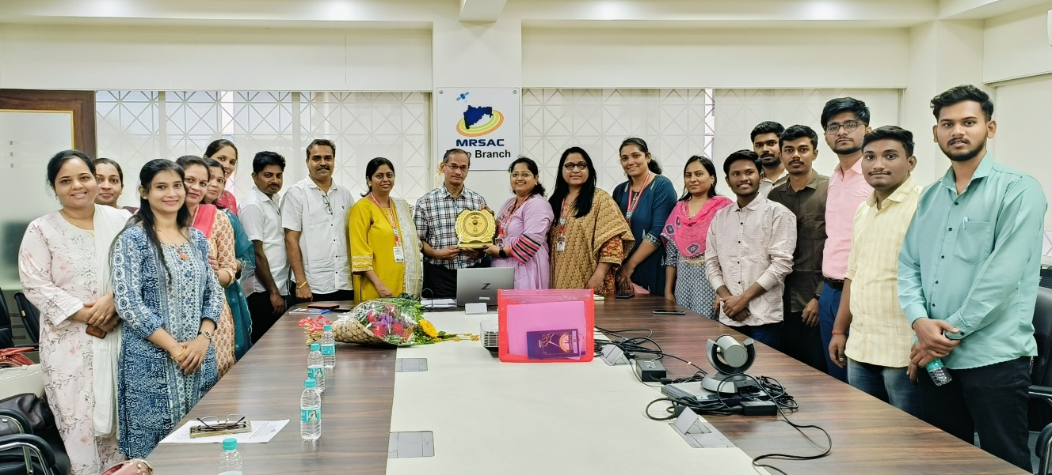
Dr. Sanjay Patil’s engaging presentation on GIS and remote sensing was both enlightening and rewarding. MRSAC, aligned with the Planning Department of Maharashtra, operates additional centers in Mumbai (2013) and Pune (2014) to ensure effective project management and prompt decisions. Its initiatives include equipping government officials, NGOs, and students with essential soft skills and technical training. Utilizing a comprehensive digital database and modern technology, MRSAC provides vital scientific guidance across diverse fields. Known for its excellence in Natural Resource Management and GIS, MRSAC reaffirms its dedication to a transparent, progressive, and e-enabled Maharashtra.
Photo: Industry Visit at MASAC,Pune.
Prepared By
Dr. Shekhar Sayajirao Chavan

